We will be using latest and greatest technologies for developing this web application.

You need to develop a web application using .net core 3.1 and angular.

Use EF for data transactions

1. Create a master page for this application. screen3 below
2. Display username on top right corner of the master page.
3. Use css for the entire application
4. User authentication using Active directory
5. Requestor name and email should be auto-populated based on AD information, read only fields
6. Request description editable textbox.
7. Customer request type, 4 radio buttons
8. Based on radio button the first box populates with list of values.(write an API to get data from DB)
9. Select values from first listbox and move them to second listbox
10. Start and end dates, use calendar control
11. Submit should save these values to DB.(write an API)

Screen 1

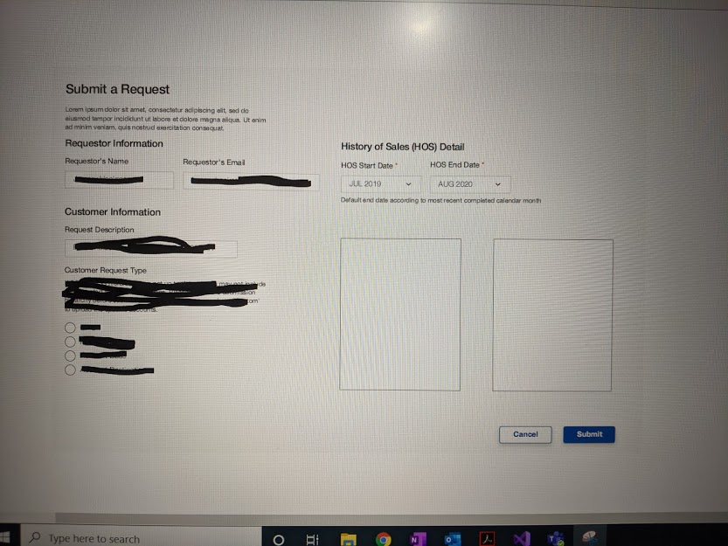

1. Once the above values are saved, they should be visible on the below screen.(write an API to get data from DB)
2. The new Request button should take it back to the previous screen.
3. Infact on application launch, screen2 is the landing page.
4. It displays requests made by that particular user.

Screen 2

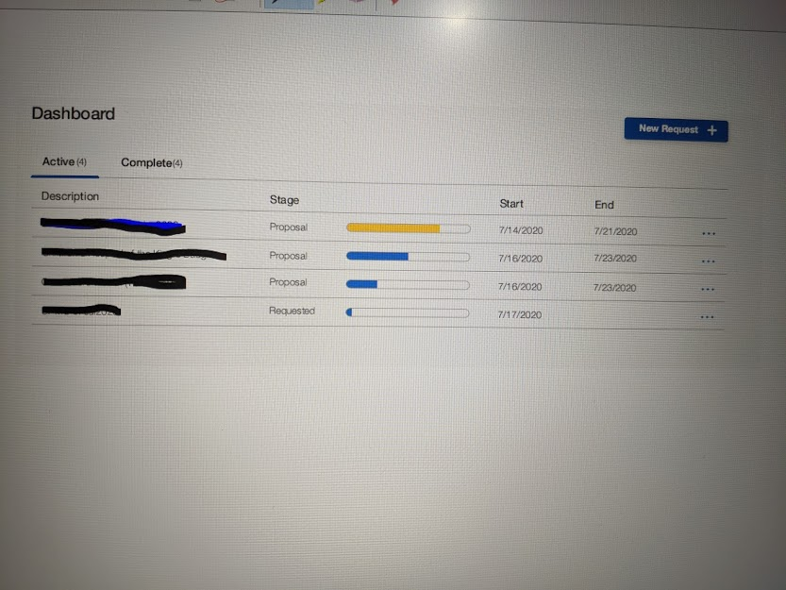

1. All this should be in a single solution with multiple projects each for APIs, UI and EF model.
2. Use stored procedures where ever required.
3. You have to ensure that you provide all instructions to set up, build and run this application on my machine.

Screen 3

